Webinar on Research Methodology
The Department of Economics, Government K.N.M. Arts and Science College, Kanjiramkulam conducted a webinar entitled ‘Breathing Life into Research: The Magical Ways of Methodology’ on 05/11/2020 for the Students of Department of Economics, Government KNM Arts and Science College, Kanjiramkulam as well as for the research aspirants across various institutions in Kerala. The webinar was delivered through online platform via Google Meet.
The webinar was intended to disseminate knowledge relating to the methods and methodology in Social science. Dr.Christabell P.J, Associate Professor, Department of Economics, University of Kerala was the resource person. The webinar was inaugurated by Dr.Sameer S., Vice-Principal, Government K.N.M. Arts and Science College, Kanjiramkulam. The programme began at 11 a.m. and ended at 12.45 p.m. The session drew a total of 98 participants, including teachers and students.
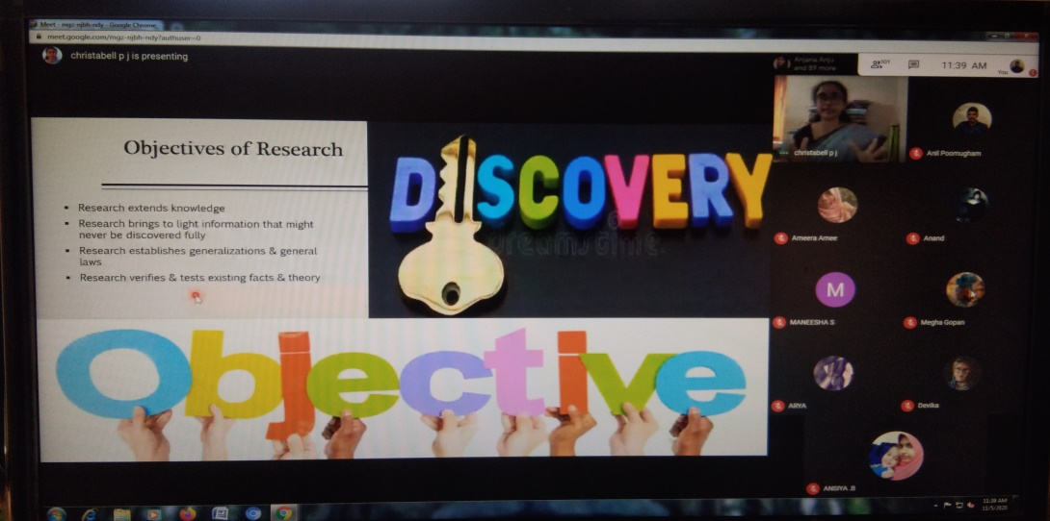
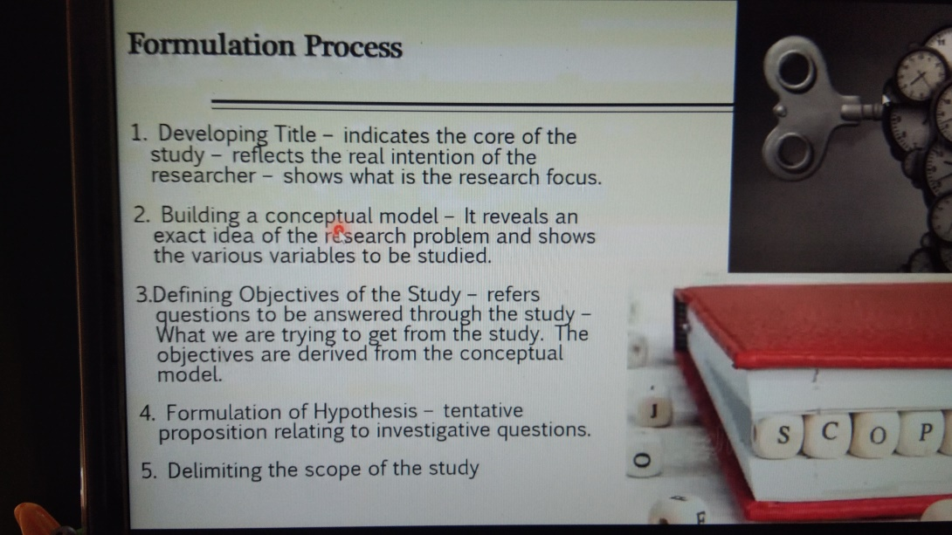
The webinar aimed at helping research scholars and students to understand about the basics of research, to provide participants a platform for discussion on the statistical requirements of research, to discuss with the students the basics of research process, to provide students insights about the types of research etc. This one-day Webinar was designed to provide participants with the fundamentals of research and research study in order to produce high-quality work. The webinar's main focus was on identifying tools and strategies for various research aims. The participants gained a thorough understanding of the different types of research, as well as the research procedure and sample process.
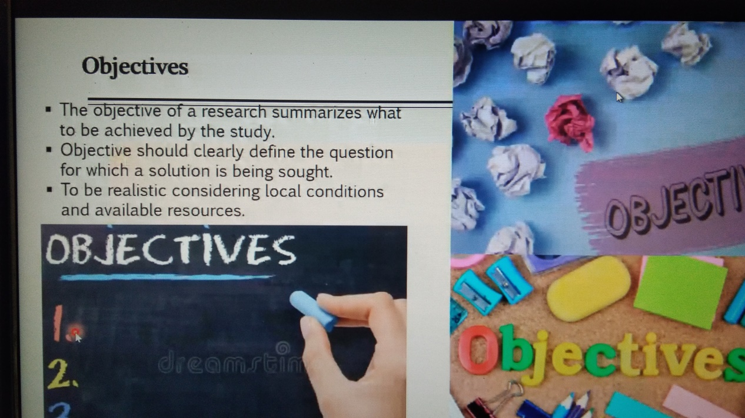
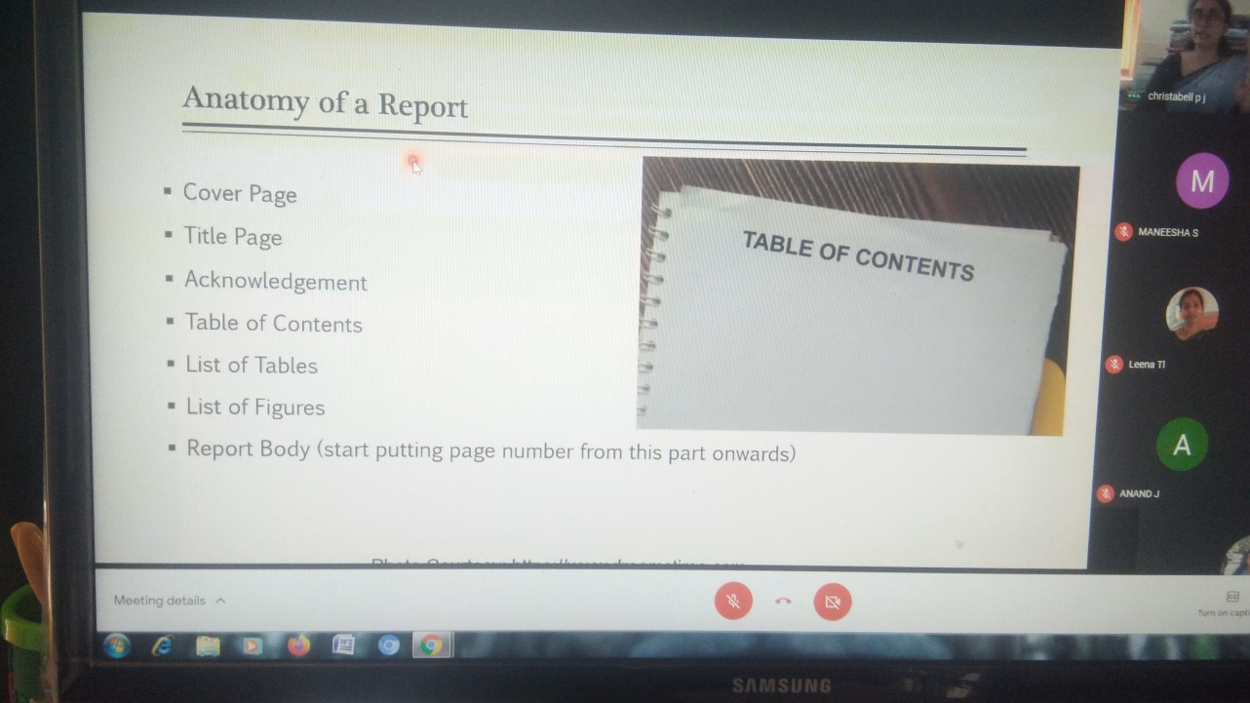

Learning outcome:
1. Participants have learnt about statistical requirements of research
2. Participants have learnt about the process of research in detail.
3. Participants have analyzed about the sampling process.
4. Participants have interpreted how to select the sample.
5. Participants have learnt about data collection, data analysis, hypothesis testing etc.
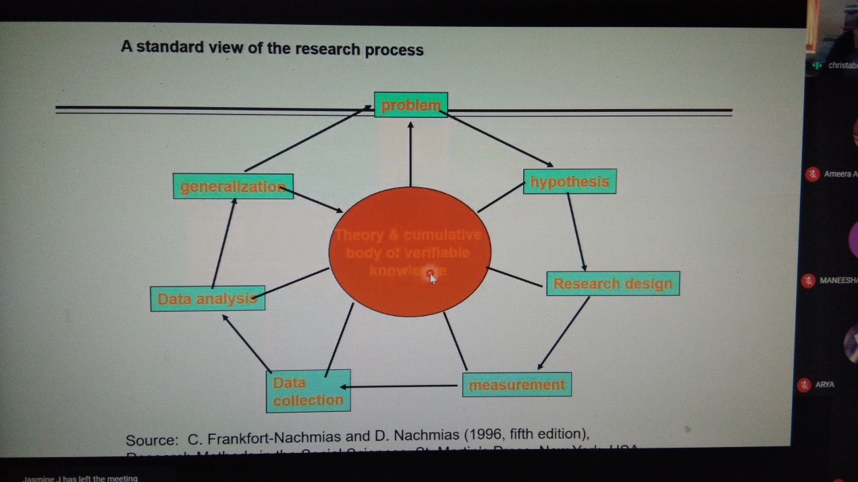
After the main presentation, there was a question and answer session. The sample technique, data collecting, statistical tools, and other topics were thoroughly explained and answered. At 12:45 p.m., the session came to a close.
Sl No. | Name of Participants
1 | Dr.Christabell P.J.
2 | Dr.Sameer S.
3 | Dr.Leena T.L.
4 | Dr,Jyothy S.Nair
5 | Anil Kumar R.
6 | Resmi R.Nair
7 | Sarjin H.
8 | ARYASREE B. S
9 | ASWANI V. S
10 | ASWATHY .S.M
11 | KAVYA VINOD.M
12 | RAKESH. R.L
13 | ROSMI.S
14 | SANGEETHA.G
15 | SARAN.R
16 | SWALIHA.S
17 | SWAPNA.S S
18 | AARYA S D
19 | AFIN A M
20 | AISHWARYA.A.V
21 | AJAY J S
22 | AMRITHA .S
23 | SARANYA S M
24 | SHABNAM .S.S
25 | SHAHINA S
26 | SHEENA S.S
27 | SREE LEKSHMI B R
28 | SREE LEKSHMI.R.A
29 | SRUTHI. S.S
30 | SRUTHY S R
31 | SRUTHY.S.C
32 | SUDHEESH KRISHNAN C S
33 | SUJI MOL. S. V
34 | SUMAN RAJ J
35 | ASHIK K
36 | CHITRA C
37 | GOVIND G
38 | KARTHIKA S S
39 | LEKSHMI P
40 | MEGHA M
41 | RAHUL S
42 | SRUTHI KRISHNAN G
43 | ABDHULLA SUHAIB
44 | ABHIJITH A
45 | ABHIJITH A B
46 | AKHIL G S
47 | AKHIL S K
48 | AKHIL V B
49 | ALI FATHIMA A
50 | ANAHA S B
51 | ANANDHU S
52 | ANIE R K
53 | ANJANA B K
54 | ANNIE J S
55 | MANSOORA FATHIMA M J
56 | MOHAMMED ABDHUL KHADER MEERAN S
57 | NOUFIYA F
58 | PRADEEP P
59 | RAJAMMA S
60 | REVATHY S D
61 | SAHAD SHA S
62 | SAHIRA BEEVI M S
63 | SALIHA BEEVI MS
64 | SANI N S
65 | SOORAJ S J
66 | VARSHA J EUGIN
67 | VIPIN GEORGE
68 | BILAL ABDHULLA N
69 | ATHIRA G
70 | ATHIRA R S
71 | BINCY B
72 | DEVIKA A U
73 | DEVIKA M S
74 | FEBIN K S
75 | JASMINE J
76 | JIJIN S W
77 | JOSHI G
78 | KIRAN V G
79 | MANEESHA M
80 | AMALROOP R I
81 | ANANDHA KRISHNAN S B
82 | ANEESHA V
83 | ANU A A
84 | ARYA S
85 | ABHIJITH V. L
86 | AAKASH M B
87 | A.J ANJANA PRAKASH
88 | ARCHANA M V
89 | KARISHMA A G
90 | MEENU S. SURESH
91 | NOUFIYA S S
92 | PARVATHY S. NAIR
93 | SAMJU G S
94 | SRUTHY S
95 | SURYAKALA K S
96 | VIGNESH N S
97 | ABHINAND G S
98 | ABHIRAMI S P

Mrs.Resmi R. Nair Mr. Anil Kumar R.
Co-Ordinator HOD of Economics

